Corporate Members
Platinum Sponsors

Gold Sponsors
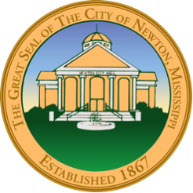
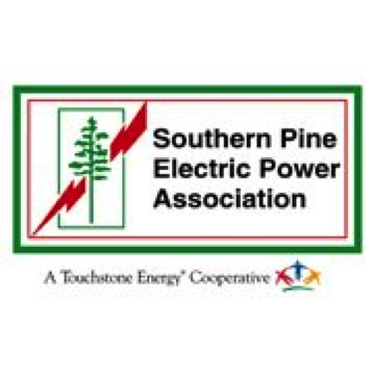
Silver Sponsors

Businesses

BankFirst
BankPlus
Bedford Care Center of Newton
Blackwell Accounting
Biewer Sawmill- Newton
Bokays and Balloons
Capital Oil, Inc.
Carla's Chop Shop
Carleton Realty
Cash Money, LLC
Chunky Shoals Fish Camp
Church Street Cakery
Circle C Investments
City of Newton
Community Partners Federal Credit Union
Decatur Family Medical Clinic- Decatur
Dezignz By Nikki
Edmund J. Phillips, Attorney at Law
Lee Blackburn, Edward Jones
ESCO
Factory Connection
Family Medical Clinic-Meridian
Family Medical Group of Union
Jason Williams, Farm Bureau Insurance
FLM Insurance
Forest & Associates Real Estate, LLC
Generations Care, LLC
Greater Decatur Chamber of Commerce
Green Thumb Outdoors
Hailey's Hardware
Harthcock-Graham Insurance
Harvest Moon Farmers Market
Heavenly Grace HomeCare Inc.
Hickory Pick'N Flea Market
Hollingsworth Dental Clinic
Horton’s Plumbing Service
Inn The Oaks Bed & Breakfast
Innovative Behavioral Services, Inc. -Tobacco Free Coalition
ITG Consulting, LLC
Ivey Rental Company
Ivey Self Storage
Jackson Hewitt Tax Service
J. Tyler McCaughn, PLLC
K&K Apparel
Keepsake Images LLC
LA Dance Studio
Laird Hospital Inc.
Landscape Management Group
La-Z-Boy
Lazy Acres Agritainment, LLC
Logan and Mayo, P.A.
MagnoliaMedia
MaxxSouth Broadband
McDonald & Hill, Inc
Miller Gymnastics, Tumbling, and Cheerleading
Mississippi Power Association
Mr. Mike's Frozen Yogurt
Ms. Nikkis Little Angel
Newton County Farm Supply
Newton County Funeral Home
Newton Discount Tobacco
Newton Eye Care
Newton Family Dental Clinic, P.A.
Newton Family Medical
Newton Finance, LLC
Newton Health Care
Newton Historical Cultural Commission
Newton Mini Storage
Newton Transmission
Northside Plaza, Inc.
Nu-Way Dry Cleaners
Perfect Ten Nail Salon
Pheanice's Sweet Creations Bakery
Picture This
Pinson's Bargain Center
Pretty Presentations Catering
Rapid Rentals
Regions Bank
Richton Tie & Timber, LLC
Rush Medical Clinic-Philadelphia
Rush Medical Clinic-Collinsville
S & S Trailer Sales, LLC
Sherry's Catering
SouthernAg Credit
Southern Pine Electric
Specialtees, Etc
State Farm Insurance, Bob Douglas
Subway of Newton, QSM, Inc.
The Newton County Appeal
The Trading Post Company
T&J Concessions
Uptown Ellie Boutique
Zack Garvin's Original Steak House, Inc.

Civic/Church
Jefferson Davis #1862 SCV Camp
Liberty Community Club
Newton Theater Company

Newton Rotary Club
Newton United Methodist Church
The Sanctuary of Newton

Individuals
Andy and Dottie Armstrong
Jamie and Brandi Baucum
Henry Beamon
Bob and Tina Bridges
Dr. Nola Bryant
Senator Terry C. Burton
Mike and Karla Butler
David Carr
Randy Cuchens
Jeff and Julie Davis
Bill and Karen Freeman
Frank Kirtley
Van and Kay Lucas
Nita McCullough
Eva McDonald
Ginger McMillan
George and Lynn Monroe
Phyllis Morrison
James Mowdy
Edward & Yvette Otkins
Charles Scoggin
Mary Beth Thomas
Dr. Steve and Paulette Tramill
Don and Jeanne Vares
Lynn Wagner
Debbie Wall
Mayor Murray and Janet Weems
Leigh Anne Whittle
Wilmer and Jessie Whittle

